Project Design Phase
Solution Architecture
Date | September 2026
Project Name | ServiceNow-Based Employee Laptop Request Application

Solution Architecture:
The solution architecture defines how the ServiceNow-based employee laptop request application connects users, request workflows, approvals, asset information, notifications, and reporting. The architecture is designed to provide a centralized and transparent process for submitting, approving, tracking, and fulfilling laptop requests.
• Provide employees with a simple interface to submit laptop requests and view request status.
• Use ServiceNow workflow and approval rules to route requests to the appropriate managers or approvers.
• Validate request information and maintain request, employee, and asset records in ServiceNow.
• Check laptop availability and support assignment of an available device to the employee.
• Send notifications for request submission, approval decisions, status changes, and fulfillment updates.
• Provide role-based access and reporting so employees, managers, and IT teams see the information relevant to them.
Project Solution Architecture Diagram:
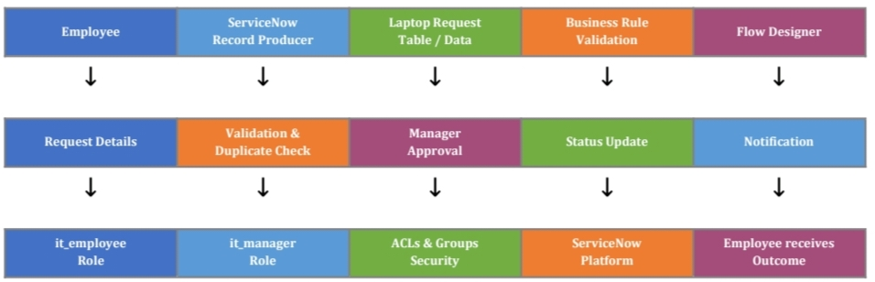
Figure 1: Solution architecture and information flow for the ServiceNow-based employee laptop request application.
Architecture Components:

Component | Purpose in the Project | Technology / Platform
User Interface | Employee request form, request history, and status view. | ServiceNow Service Portal / UI
Application Logic | Request validation, workflow routing, approval rules, and status updates. | ServiceNow Workflows / Flow Designer / Business Rules
Request Data | Stores laptop requests, approvals, comments, and request status. | ServiceNow tables / database
Asset & CMDB | Checks laptop availability and supports asset assignment and tracking. | ServiceNow Asset Management / CMDB
Notifications | Communicates submission, approval, rejection, and fulfillment updates. | ServiceNow Notifications / Email
Security | Controls access based on employee, manager, and IT roles. | ServiceNow Roles / ACLs
Reporting | Provides request, approval, fulfillment, and status reports. | ServiceNow Reports / Dashboards

